**Customer Segments for Sun Country and Increasing Ufly Membership**

Prepared By: Aakriti Aneja, Hao Cheng, Shubham Garg, Jichen Liu, Maria Moy, and Congyi Zhang

**How did we analyze the data?**

Our analysis aimed to find meaningful customer segments to increase Ufly membership and Sun Country Airline (SCA) Website Booking. First, we clustered our customers into meaningful groups based on similar flying traits. Clustering puts customers with similar characteristics in the same group and customers with different features in different groups. Second, we looked at how long it takes to become a Ufly member. Finally, combining the cluster solution with the Ufly membership analysis, we recommended targeting specific clusters to improve Ufly membership and increase SCA Website bookings. These insights will allow Sun Country to understand better who its customers are and meet their customers' needs through Ufly membership.

**How are our customers clustered?**

1. The first cluster is “Frequent 1st-Class Flyers” because 27.8% of the customers in this cluster are repeated flyers, and 87.7% of flights taken in the clusters are first-class flights. On average, this cluster spent $622 on a flight, which is $200 more than any other cluster. This is the smallest cluster, with 2.4% of all customers. Of the 38% of customers in the cluster who are Ufly members, 97.3% are Standard members.
2. The second cluster is “One Time Low Spenders.” This cluster has only 8% repeat flyers, which is 5% less than any other cluster. This cluster is distinct by how, on average, customers spend $107 per flight, which is over $200 less than any other cluster.
3. The “SCA Bookers” cluster is defined by how over 99% of the bookings come from the SCA Website or SY Vacation. This is the largest cluster with 617,000 customers, which is 40% of all SCA customers. Repeat flyers in this cluster are 16%, which is the median of all the clusters.
4. The fourth cluster is “Outside Bookers” This cluster almost exclusively books from outside channels, any website other than SCA Website or SY Vacation. There is a cluster size of 415,000 customers, with 27% of all customers, and the most popular time to fly is in Quarter 3. It also has the second lowest membership proportion, 11% of customers being members.
5. The last cluster, “Upgraders,” is distinctly defined by the percentage of seat upgrades. This cluster has 70% of all the upgraded flights among all the clusters, which is 65% more upgrades than any other cluster. They spend an average of $316 per flight, and 19.6% of customers are repeat flyers. They make up 70% of all upgrades yet only purchase 3.5% of first-class flight purchases.

**How do the different memberships differ regarding the number of flights and the amount spent?**

On average, non-members take two flights and spend $307, Standard members take 2.5 flights and spend $337, and Elite members take eleven flights and spend $460. On average, repeat flyers for non-members are 10%, 24% for Standard members, and 63% for Elite Members.

**What recommendations can we make based on the clusters and Ufly analysis?**

1. *Target Potential Elite members in “Frequent 1st-Class Flyers”*. Potential Elite members are ones that took 7 to 9 flights with Sun Country. Focusing on this cluster is advantageous because they are the highest spenders (based on average ticket price), Ufly Standard membership is high yet Elite status is low, and customers are using Elite benefits, evident by purchasing first-class flights. A large portion of Ufly Standard members and repeat flyers in this cluster is evidence of loyal customers. For Sun Country, targeting these customers means better customer relationships through stronger customer loyalty. Being the smallest cluster with 37,000 customers, Sun Country can effectively target a small number of customers to maximize its returns.
2. *Incentivize current Ufly members in the “Outside Bookers” cluster to book through the SCA website through earning more points per flight purchase.* “Outside Bookers” currently purchase 99% of tickets on outside booking channels. Every outside booking takes away some revenue from SCA because the outside channels take a small cut of the ticket price. SCA can target Ufly members, which is 11% of the cluster. Of the Ufly members, 36% are repeat flyers, whereas the cluster overall has 13% repeat flyers. Having SCA incentivize by earning more points on the SCA website, Ufly members in the “Outside Bookers” cluster benefit by earning more points from SCA Website booking than outside bookings. For Sun Country, targeting these customers means not sharing revenue with an outside booking organization, increased customer loyalty as the Ufly members will accumulate points to be redeemed on future flight tickets, and more efficiently targeting marketing to 42,000 customers instead of the entire cluster of 415,000 customers.

**Figure 1: Cluster Summary**

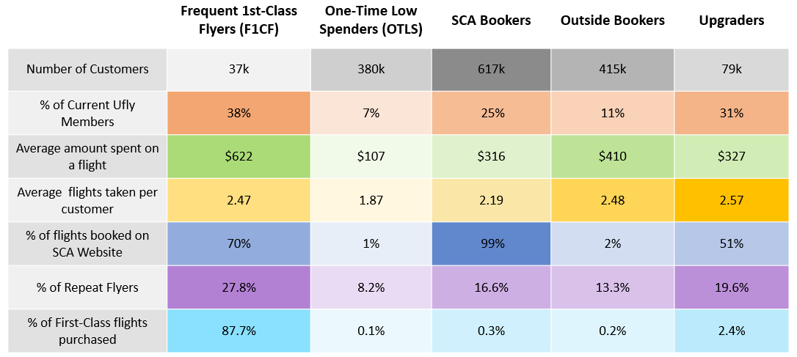

**Figure 2: Membership Summary**

